**The 9th Brett Pearson Run** ***for Your Life***

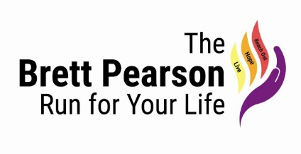

***Supporter of the Canadian Armed forces***

***First Responders (Police, Fire, Paramedics)***



September 28th 2019

9am to 2pm

Carleton Place Town Square

15 Mill Street, Carleton Place, ON

Stay tuned to more updates

8:30am –10am REGISTRATION & SPEECHES: Carleton Place Town Square

Master of Ceremony: Mayor Doug Black

Welcome and Opening Speech to all

O’Canada, Dave Brown (Brownie)

Speeches by Honoured Guests:

**MATT SKUBE, Anchor and Reporter CTV News**

ORLANDO DA SILVA, Bencher Law Society Ontario and Senior Crown Counsel, Ontario Ministry of the Attorney General

Nicole Pearson, Mother of Brett

Father David Andrew - Prayer

10:30am –11:00am PARADE OF LIFE –Parade Marshal Dennis Pearson

Bridge Street to Lake Avenue, to Cenotaph for Ceremony at 10:45 am

Led by the Royal Canadian Legion Branch 192 Carleton Place

11:00am – START TIME 5 km Walk/Run

5km Walk/5km Run – Mississippi River Walk Trail

11:30am – 1:30pm – Entertainment

EMILY BURGESS and Musicians Ryan “Rico” Browne & Marcus Browne

12:00pm to 1:30 pm LUNCH–DOOR PRIZES & Prizes for 1st, 2nd, 3rd 5km Run race

1:45pm -2:00pm CLOSING REMARKS