The 7th Brett Pearson Run for Your Life
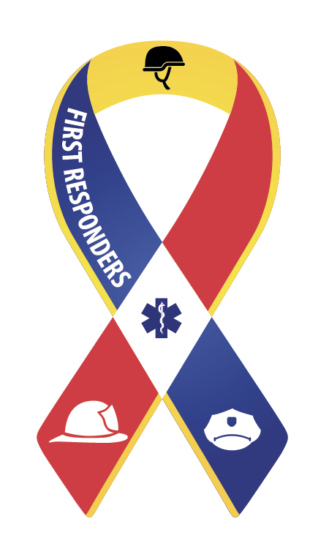
Supporter of the Canadian Armed forces
First Responders (Police, Fire, Paramedics)



September 23rd 2017
9am to 1pm
Carleton Place Town Square
15 Mill Street, Carleton Place, ON

8:30am –9:45 am REGISTRATION & SPEECHES

Master of Ceremony: Deputy Mayor Jerry Flynn
Welcome and Opening Speech to all Mayor Louis Antonakos
O’Canada, Dave Brown (Brownie)
Royal Canadian Sea Cadets Band – Lanark
MP Scott Reid, Lanark-Frontenac-Kingston

Speeches by Honoured Guests:
Doug Smith, NHL Hockey Player. Author, Motivational Speaker

Dr. Barry Dworkin, Physician, Assistant Professor Family Medicine University of Ottawa, Host Radio 580 CFRA Sunday House Call

Nicole Pearson, Mother of Brett

09:45am - Parade Form-up

10:00am –10:30am PARADE OF LIFE –Parade Marshal Dennis Pearson
Led by the Royal Canadian Legion Branch 192 Carleton Place
Act of Remembrance at Cenotaph and placement of wreaths (on Parade route)

10:30am – 11:30pm
At the Mississippi River Walk Trail -5km Walk/5km Run
New this year 10KM Relay Race
At the Main site Town Square, Mill street – Hockey Skills Competition - Prize for best scorer

11:30pm – 12:45pm – Entertainment and Lunch
LANARK COUNTY REVIVAL – Musicians David Hauraney, Jim Ryan and Tom Kemp.
DOOR PRIZES and Medals for 1st, 2nd, 3rd 5km Run and 10km Relay race.

LUNCH - BBQ provided by The Beckwith Butcher.

12:45pm -1:00pm CLOSING REMARKS

