The 6th Brett Pearson Run for Your Life
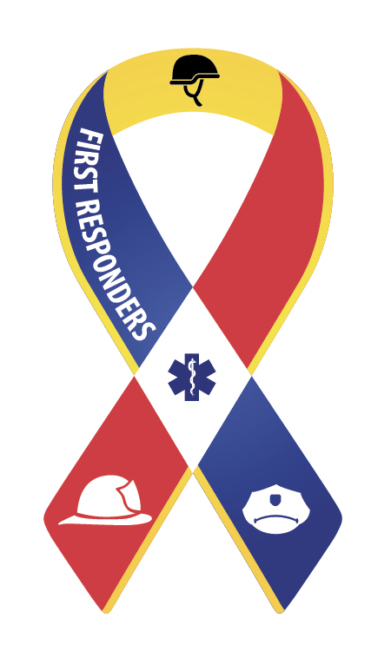
Supporter of the Canadian Armed forces
First Responders (Police, Fire, Paramedics)

September 24th 2016
9am to 1pm
Carleton Place Town Square
15 Mill Street, Carleton Place, ON

8:30am –10am REGISTRATION & SPEECHES: Carleton Place Town Square

Master of Ceremony: Deputy Mayor Jerry Flynn
Welcome and Opening Speech to all by Carleton Place Mayor Louis Antonakos
O’Canada, Dave Brown (Brownie)
Royal Canadian Sea Cadets Band – Lanark
Remarks by MP Scott Reid, Lanark-Frontenac-Lennox & Addington
(in absentia, remarks read by Brian Turner, Chair Drug Strategy Committee)

Speeches by Honoured Guests:
Kathy Donovan, author of Inspiration in Action: A Woman’s Guide to Happiness, formerly from CTV Regional Contact, Ottawa ON

Honourable Vernon White, Senator, Senate of Canada, formerly Chief of Police of the Ottawa Police Service

Nicole Pearson, Mother of Brett

Father David Andrew - Prayer

10:00am –10:30am PARADE “Walk of Life” –Parade Marshal Dennis Pearson
Led by the Royal Canadian Legion Branch 192 Carleton Place.

10:30am – START TIME 5 km Walk/Run
5km Walk – Downtown Carleton Place
5km Run – Mississippi River Walk Trail

12:00pm – 1:00pm – Entertainment
SOUNDS SWEET – Musical duo Jennifer Hoy and David HauraneyLUNCH – DOOR PRIZES – CLOSING REMARKS

