The 5th Brett Pearson Run for Your Life
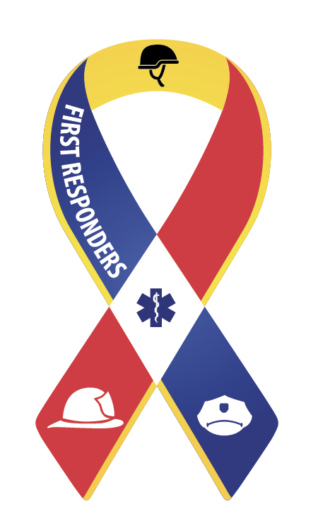
Supporter of the Canadian Armed forces
and
First Responders (Police, Fire, Paramedics)

September 26th 2015
9am to 1pm
Carleton Place Town Square
15 Mill Street
Carleton Place, ON

8:30am –10am REGISTRATION & SPEECHES: Carleton Place Town Square

Master of Ceremony: Deputy Mayor Jerry Flynn
Welcome and Opening Speech to all by Carleton Place Mayor Louis Antonakos
O’Canada, Dave Brown (Brownie)
Royal Canadian Sea Cadets Band – Lanark
Carleton Place and District Band
Remarks by MP Scott Reid, Lanark-Frontenac-Lennox & Addington

Speeches by Honoured Guests:
Tom Gabriel (Dipl.) ACW, ICADC (ret. Police Constable), Toronto, ON
Sgt. Rob Croth, Ontario Provincial Police, Carleton Place Detachment
Ron Goebel, Vice Chairman, Ontario Provincial Command, Royal Canadian Legion
Les Reynolds, Fire Chief, Town of Carleton Place
Ed McPherson, Chief Lanark County Ambulance Service
Dr. Manuela Joannou, Physician, Perth, ON
Sgt. James Ward, York Regional Police, co-founder I Run and Rock United by Trauma
Nicole Pearson, Mother of Brett
Father David Andrew, St James Anglican Church

10:00am –10:30am PARADE “Walk of Life” –Parade Marshal Dennis Pearson

10:30am – START TIME 5 km Walk/Run
5km Walk – Downtown Carleton Place
5km Run – Mississippi River Walk Trail
12:00pm – 1:00pm – Entertainment
Leith Ross, Vocalist, Ottawa, ON.
LUNCH – DOOR PRIZES – CLOSING REMARKS

Parade Walk of Life: Walkers and runners will be led by a parade headed by Brett’s mother Nicole and Brett's brother Dennis leading the way. The parade will travel down Bridge Street in Carleton Place.
Kiosk Opportunities: Healthcare and volunteer organizations are invited to host display booths offering opportunities for the public to learn more about resources available for those at risk or in need.

Registration: Registration is being handled by Events Online. To register, simply visit our website at www.cpdrugstrategy.com and click on Events (Brett Pearson event 2015) or www.EventsOnline.com. Individual registration fee for the 5 km walk/run is $35.

Team Challenge: challenge is being issued and participants are encouraged to sign up in teams, either as a group or as a family, schools, or even work colleagues. The cost per person in a team is $25. Teams are encouraged to come up with a name for their team, assign a Captain and there is no limit to the number of participants per team.
Pledges: Those looking to print a pledge sheet can do so from the website www.cpdrugstrategy.com. Those unable to attend the walk/run, but wishing to make a donation may do so by visiting any Scotiabank branch in Carleton Place, Ottawa, Kanata and Stittsville and indicating their donation is for the Brett Pearson Memorial Run c/o The Town of Carleton Place or they can mail a cheque payable to the same fund name to the Town of Carleton Place, 175 Bridge St., Carleton Place, ON K7C 2V8
Event day: Register at Town Square from 8:30 AM to 10 AM on September 26th. Race kits will be available to those registered on-line and the morning of the event, complete with lunch ticket, t-shirt and more.
Volunteers are also being sought to help out at the registration site and at the Mississippi River Walk Trail. Please contact us through our website.
Nicole Pearson, Brett’s mother says; "The money (raised) is turned back into our community to help members of the Canadian Armed Forces and First Responders.” A portion of the proceeds will be donated to the charity “I Run for Rock United by Trauma”
Contact: Nicole Pearson at hope.cp66@yahoo.ca Visit our Facebook page at https://www.facebook.com/BrettPearsonRunForYourLife

